Module 3 Report:

1. What is the Windows Registry?
According to Magnet AXIOM, the Windows Registry is “a database that stores configuration information and settings for the Microsoft Windows operating system and its applications.”
2. What are the four main Global registry hives and the main User registry hive?
The four main Global registry hives are the SAM, SECURITY, SOFTWARE, and SYSTEM hives. The main User registry hive is NTUSER.DAT and UsrClass.dat.
3. How many partitions does the computer have?
There is a total of 5 partitions on the computer.
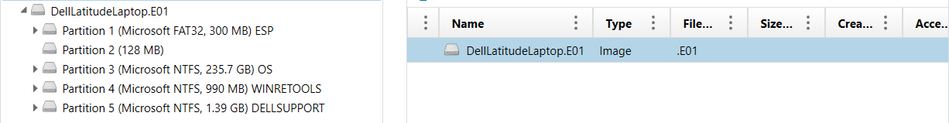
4. What is the volume name of the largest partition on the computer?
The volume name of the largest partition on the computer is “Partition 3 (Microsoft NTFS, 235.7 GB) OS”

5. What operating system is on the computer and what is the version number?
The operating system on the computer is Windows 11 Core (2009) and the version number is 6.3.
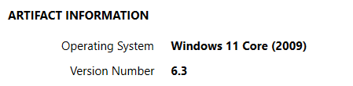

6. What is the email address of the owner of the operating system?
The email address of the owner of the operating system is ryanJennings1842@outlook.com.
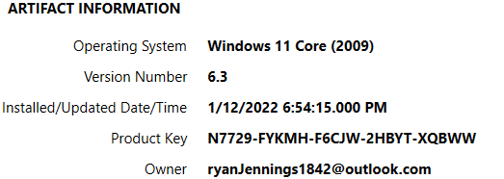
7. Which user account was created first on the computer?
The user account that was created first was ryanJ.
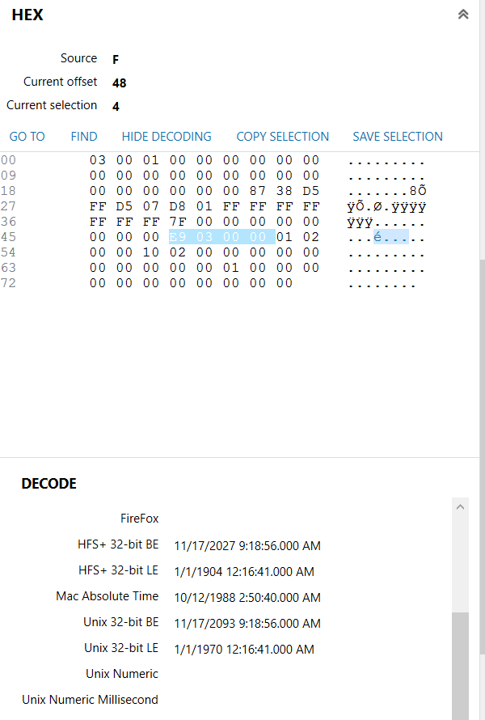

8. When the computer was last connected to the Ethernet adapter, it was assigned an IP address of 172.11.92.147. How long is the lease period for this IP address?
The lease period for the 172.11.92.147 is from 12/20/2021 8:38:12.000 AM to 12/20/2021 12:38:12.000 PM which is exactly 4 hours.
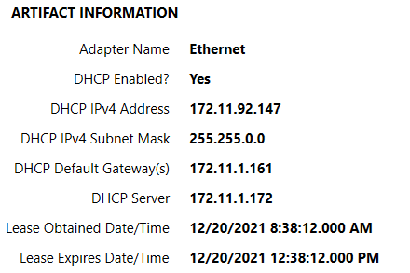
9. True or False. The program OneDrive is configured to start up when the computer starts and is configured to run in the background.
True.
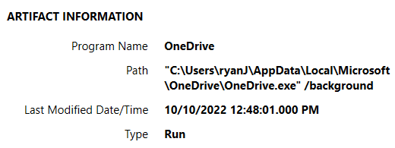

10. What version of the program Signal is installed on the computer?
The version of the program Signal that is installed on the computer is version 5.58.0.
